November 2020 Registration Form

Candidate Details
Please give your entry details exactly as your UCAS application and/or your Passport or National ID
First Name(s)
Family Name
Date of Birth
Gender
UCAS Personal ID
Address

Post Code
Email
Telephone

Admissions Test Type
Please select the Admissions Test you wish to register for in the drop down menu below
Test Type | Choose an item.

Which Universities are you applying to?
University Name
Name of Course
Course Code
University Name
Name of Course
Course Code
University Name
Name of Course
Course Code

Do you require Access Arrangements?
Request for modified papers must be received by 17:00 on 15th October 2020
Details of Arrangements Needed
Reason for Access Arrangements
*Medical Documents supporting your access arrangement request must be submitted
with your application

Candidate Signature
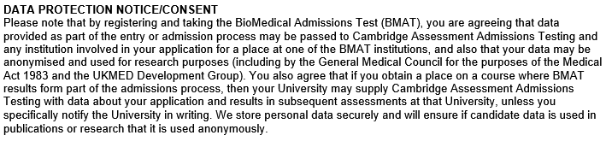

Signature _____________________ Date _____________

Once completed, please return this form to info@louthenglish.ie
To make a payment for your test please click here. You will be redirected to the Louth English website, booking section.

